COMPUTER NETWORKS

BCSE308P

LAB WORK – 2

NAME: Adhithya Kumar Tummala

REG NO: 24BCE1588

1. Creating Hybrid Topology:
This code implements a 25-node Complex Hybrid Network Topology in Scilab using the NARVAL toolbox. It simulates a large-scale enterprise network by integrating three distinct architectural patterns—Mesh, Star, and Ring—into a single interconnected system.
Nodes 1–10 (Mesh)
Nodes 11–17 (Star)
Nodes 18–25 (Ring)
Code:
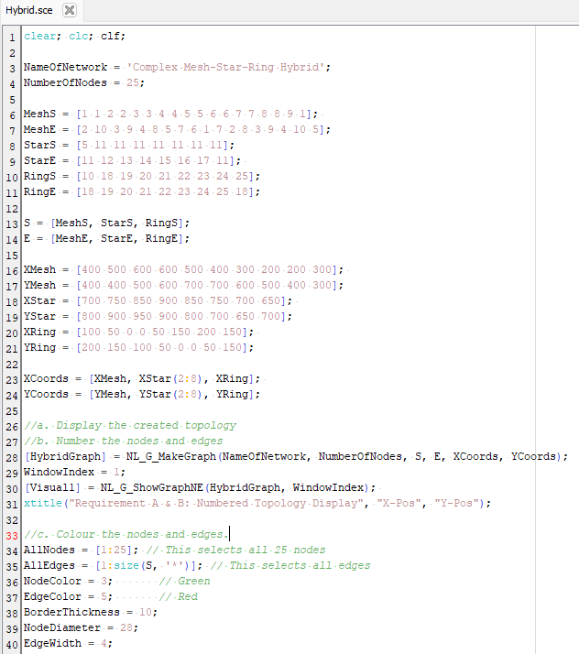
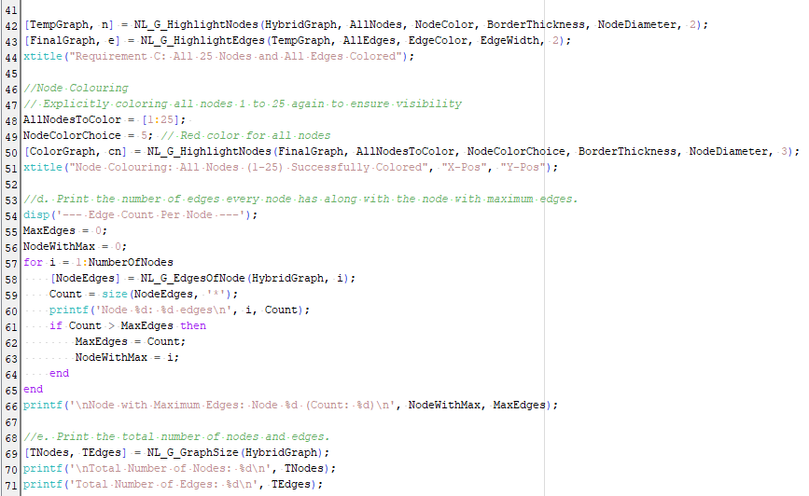
Output:
1. Display the created topology:
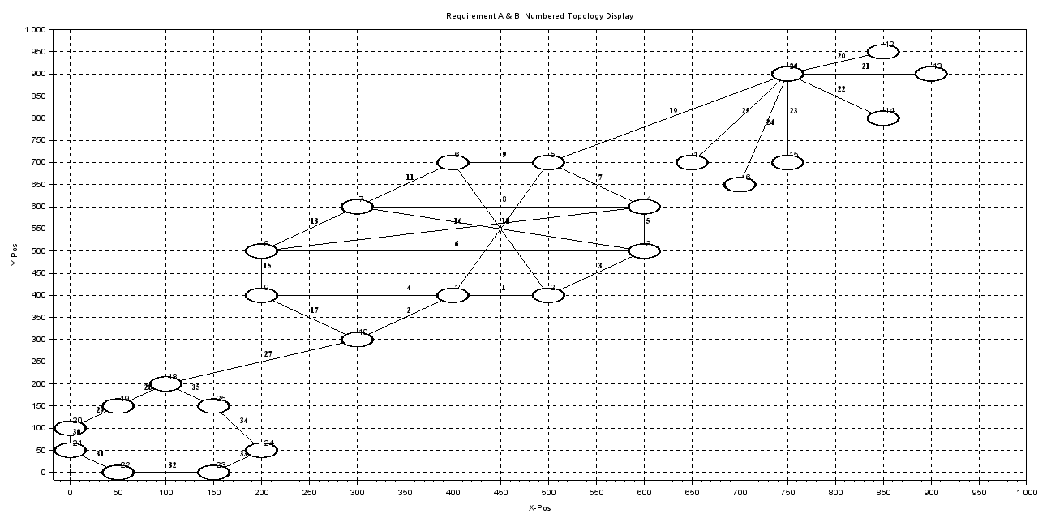

2. Coloring the nodes

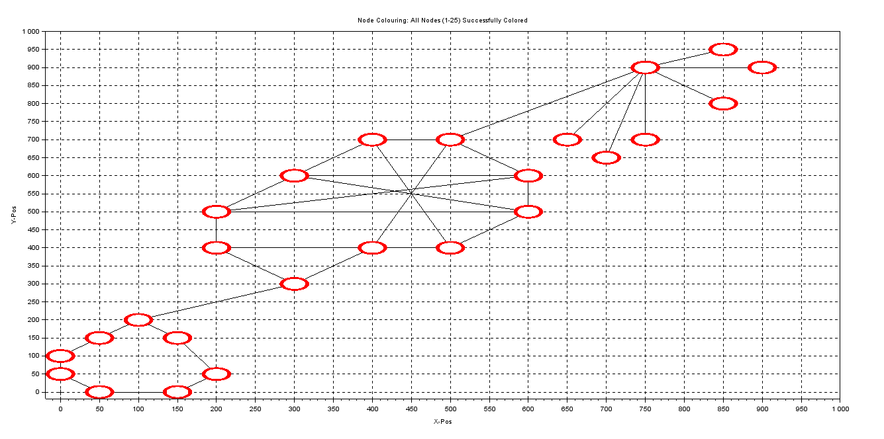
3. Coloring the edges

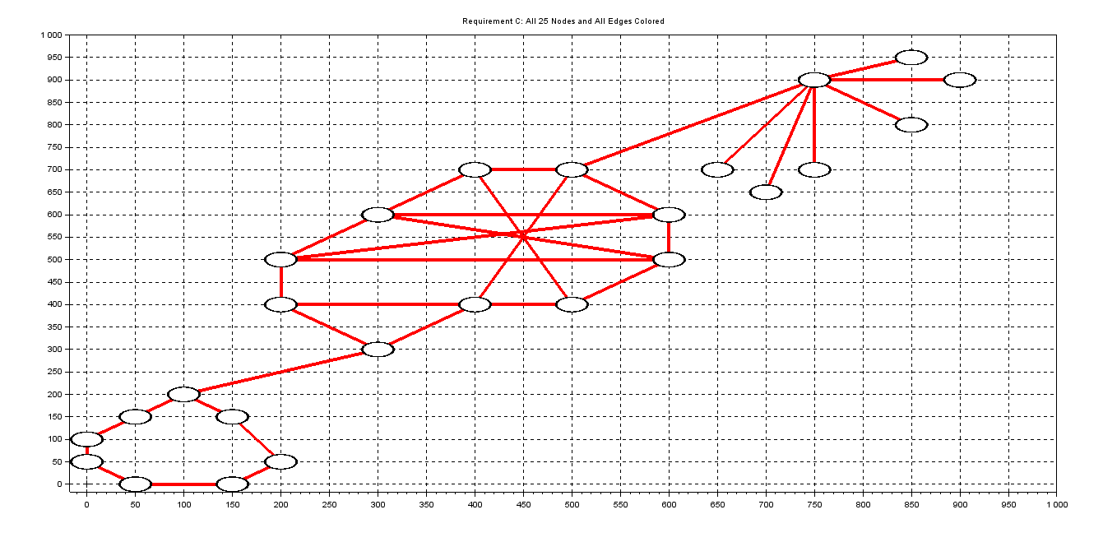
4. Print the number of edges every node has along with the node with maximum edges.
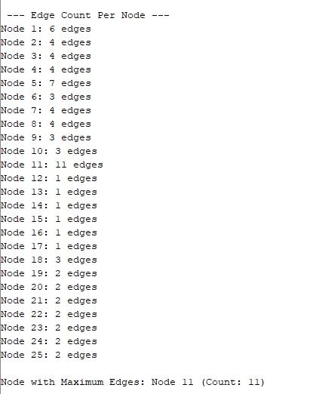
5. Print the total number of nodes and edges.
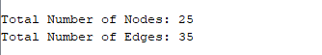

2. Scenario Based Question:

VIT Chennai is hosting its annual fest, VIBRANCE. To manage the event, the technical team has deployed a 25-node hybrid network to connect different zones of the campus:
- The Admin & Server Core (Nodes 1–10): A Mesh Topology is used in the Netaji Subhas Chandra Bose (NSCB) Block. This serves as the "Backbone" to ensure that if one cable is tripped over by a student, the main servers stay online via redundant paths.
- The Food Court & Stalls (Nodes 11–17): A Star Topology is set up at the Gazebo/Food Court area. All digital payment scanners connect to a central Hub (Node 11) for quick processing.
- The Smart Lighting Ring (Nodes 18–25): A Ring Topology is used around the Open Air Theatre (OAT) to control the decorative LED lights in a continuous loop.

